HANGMAN

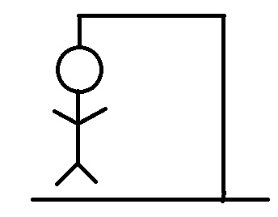

By – Arshita Marwaha

Index

|  |  |  |
| --- | --- | --- |
| Sl no | contents | Pg no |
| 1 | introduction | 1 |
| 2 | System requirements | 2 |
| 3 | database | 3-5 |
| 4 | Java code | 6-65 |
| 5 | bibliography | 66 |

Introduction

[Project description]

The game ‘Hangman’ is a popular, interactive group activity which involves players attempting to guess a word given a number of blank spaces.

Players guess letters which they feel, would be suitable to complete the word. But the catch here is that there are a limited number of guesses allowed, with each incorrect guess resulting in the stick figure ‘man’ getting one step closer to being ‘hung’.

In case the player succeeds in guessing the entre word before the man hangs, he/she wins!

This project is an attempt to recreate this game in a computerised manner for players to test themselves against a number of words predetermined by the system. It aims to make this process exciting and fun. We hope you enjoy it as much as we enjoyed making it!

SYSTEM REQUIREMENTS

SOFTWARE REQUIREMENTS:

* WINDOWS XP and higher versions
* FRONT END: NetBeans IDE 8.0.2 or above
* BACKEND: MySQL

HARDWARE REQUIREMENTS:

* RAM – 256 MB or higher
* Processor – Intel Pentium 3 or higher

DATABASE

Sql code for table creation:

>create database hangman;

>use hangman;

>create table moveasy(slno int(3), moviename varchar(20));

>insert into moveasy values(1,’titanic’);

>insert into moveasy values(2,’up’);

>insert into moveasy values(3,’jaws’);

>insert into moveasy values(4,’shrek’);

>insert into moveasy values(5,’zootopia’);

>insert into moveasy values(6,’avatar’);

>insert into moveasy values(7,’saw’);

>insert into moveasy values(8,’sully’);

>insert into moveasy values(9,’aladdin’);

>insert into moveasy values(10,’rio’);

>select * from moveasy;

|  |  |
| --- | --- |
| Slno | Moviename |
| 1 | Titanic |
| 2 | Up |
| 3 | Jaws |
| 4 | Shrek |
| 5 | Zootopia |
| 6 | Avatar |
| 7 | Saw |
| 8 | Sully |
| 9 | Aladdin |
| 10 | Rio |

>create table movmed(slno int(3), moviename varchar(20));

>insert into movmed values(1,’gladiator’);

>insert into movmed values(2,’scarface’);

>insert into movmed values(3,’vertigo’);

>insert into movmed values(4,’maleficent’);

>insert into movmed values(5,’pinnochio’);

>insert into movmed values(6,’quadrophenia’);

>insert into movmed values(7,’octopussy’);

>insert into movmed values(8,’predator’);

>insert into movmed values(9,’martian’);

>insert into movmed values(10,’divergent’);

>select * from movmed;

|  |  |
| --- | --- |
| Slno | Moviename |
| 1 | Gladiator |
| 2 | Scarface |
| 3 | Vertige |
| 4 | Maleficent |
| 5 | Pinnochio |
| 6 | Quadrophenia |
| 7 | Octopussy |
| 8 | Predator |
| 9 | Martian |
| 10 | Divergent |

>create table movhard(slno int(3), moviename varchar(20));

>insert into movhard values(1,’alien’);

>insert into movhard values(2,’casablanca’);

>insert into movhard values(3,’godzilla’);

>insert into movhard values(4,’inception’);

>insert into movhard values(5,’madagascar’);

>insert into movhard values(6,’logan’);

>insert into movhard values(7,’sorcerer’);

>insert into movhard values(8,’cellular’);

>insert into movhard values(9,’dictator’);

>insert into movhard values(10,’grudge’);

>select * from movhard;

|  |  |
| --- | --- |
| Slno | Moviename |
| 1 | Alien |
| 2 | Casablanca |
| 3 | Godzilla |
| 4 | Inception |
| 5 | Madagascar |
| 6 | Logan |
| 7 | Sorcerer |
| 8 | Cellular |
| 9 | Dictator |
| 10 | Grudge |

Java code

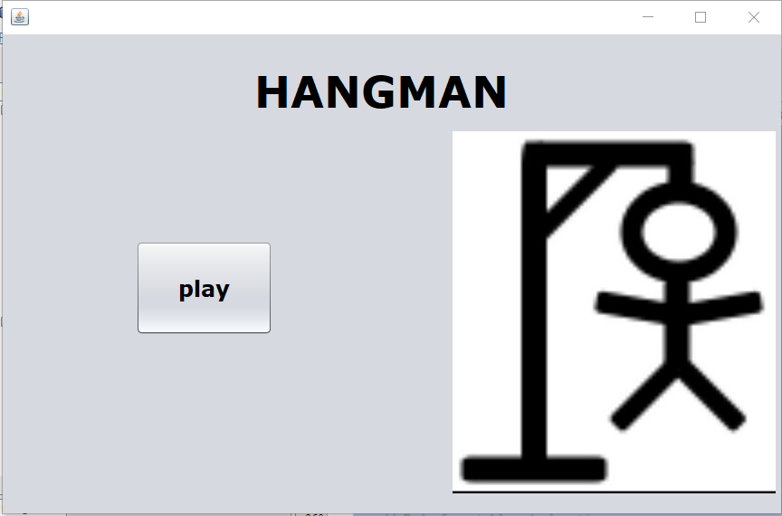

code for play button:

java.awt.EventQueue.invokeLater(new Runnable() {

public void run() {

new hangmanmain().setVisible(true);

}

});

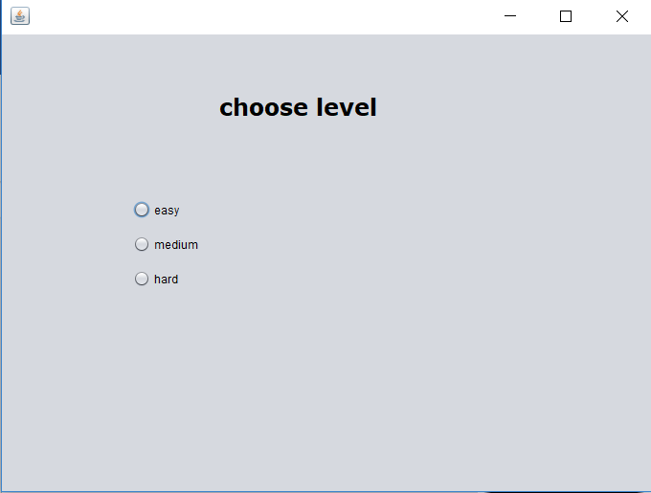

Code for easy radiobutton:

java.awt.EventQueue.invokeLater(new Runnable() {

public void run() {

new easyframe().setVisible(true);

}

});

Code for medium radiobutton:

java.awt.EventQueue.invokeLater(new Runnable() {

public void run() {

new mediumframe().setVisible(true);

}

});

Code for hard radiobutton:

java.awt.EventQueue.invokeLater(new Runnable() {

public void run() {

new hardframe().setVisible(true);

}

});

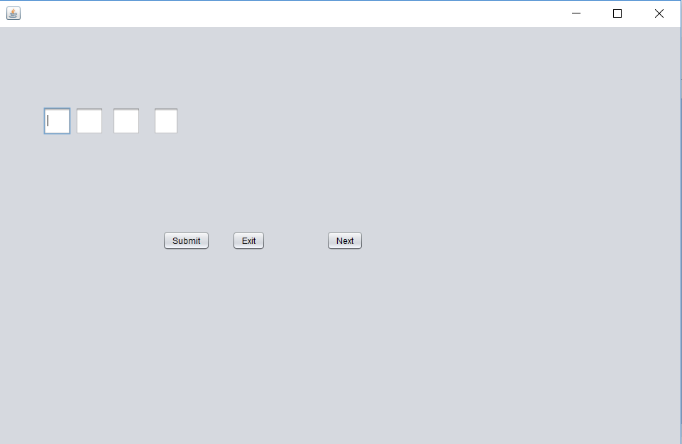

Easy.java (Code) →

IMPORT STATEMENTS

import java.sql.*;

import javax.swing.*;

EASY

public class easy extends javax.swing.JFrame {

public String name;

public int chance = 8;

public int wordLength = 0;

public int textFilled = 0;

public ResultSet rs;

public easy() {

initComponents();

jTextField1.setVisible(false);

jTextField2.setVisible(false);

jTextField3.setVisible(false);

jTextField4.setVisible(false);

jTextField5.setVisible(false);

jTextField6.setVisible(false);

jTextField7.setVisible(false);

jTextField8.setVisible(false);

jTextField9.setVisible(false);

jLabel1.setVisible(false);

jLabel2.setVisible(false);

jLabel3.setVisible(false);

jLabel4.setVisible(false);

jLabel5.setVisible(false);

jLabel6.setVisible(false);

jLabel7.setVisible(false);

try

{

Class.forName("com.mysql.jdbc.Driver");

Connection con= DriverManager.getConnection("jdbc:mysql://localhost/hangman","root","server");

Statement stmt = con.createStatement();

String query = "select movie_name from gameeasy;" ;

rs = stmt.executeQuery(query);

rs.first();

if (rs.getString(1).equals(""))

{

JOptionPane.showMessageDialog(null, "No names in database");

System.exit(0);

}

else

{

name = rs.getString(1);

}

} catch (Exception e ){JOptionPane.showMessageDialog(null, e.getMessage());}

wordLength = name.length();

System.out.print(wordLength);

int b = 9-wordLength;

System.out.print(b);

switch (b) { case 0 : jTextField9.setVisible(true);

case 1 : jTextField8.setVisible(true);

case 2 : jTextField7.setVisible(true);

case 3 : jTextField6.setVisible(true);

case 4 : jTextField5.setVisible(true);

case 5 : jTextField4.setVisible(true);

case 6 : jTextField3.setVisible(true);

case 7 : jTextField2.setVisible(true);

case 8 : jTextField1.setVisible(true);

}

}

private void initComponents() {

jTextField1 = new javax.swing.JTextField();

jButton1 = new javax.swing.JButton();

jTextField2 = new javax.swing.JTextField();

jTextField3 = new javax.swing.JTextField();

jTextField4 = new javax.swing.JTextField();

jTextField5 = new javax.swing.JTextField();

jTextField6 = new javax.swing.JTextField();

jTextField7 = new javax.swing.JTextField();

jTextField8 = new javax.swing.JTextField();

jTextField9 = new javax.swing.JTextField();

jLabel1 = new javax.swing.JLabel();

jLabel2 = new javax.swing.JLabel();

jLabel3 = new javax.swing.JLabel();

jLabel4 = new javax.swing.JLabel();

jLabel5 = new javax.swing.JLabel();

jLabel6 = new javax.swing.JLabel();

jLabel7 = new javax.swing.JLabel();

jLabel8 = new javax.swing.JLabel();

jLabel9 = new javax.swing.JLabel();

jButton2 = new javax.swing.JButton();

jButton3 = new javax.swing.JButton();

private void ManageChance()

{

chance = chance - 1;

switch (chance){

case 7 :

jLabel1.setVisible(true);

break;

case 6 :

jLabel5.setVisible(true);

break;

case 5 :

jLabel3.setVisible(true);

break;

case 4 :

jLabel2.setVisible(true);

break;

case 3:

jLabel7.setVisible(true);

break;

case 2 :

jLabel4.setVisible(true);

break;

case 1 :

jLabel6.setVisible(true);

JOptionPane.showMessageDialog(null, "Chances over. You have lost the game");

System.exit(0);

}

}

int SanityCheckOfFields()

{

String empty = "";

int notFilled = 0;

if (empty.equalsIgnoreCase(jTextField1.getText()))

{

jTextField1.grabFocus();

empty = "";

notFilled = 1;

}

else if (empty.equalsIgnoreCase(jTextField2.getText()))

{

jTextField2.grabFocus();

empty = "";

notFilled = 2;

}

else if (empty.equalsIgnoreCase(jTextField3.getText()))

{

jTextField3.grabFocus();

empty = "";

notFilled = 3;

}

else if (empty.equalsIgnoreCase(jTextField4.getText()))

{

jTextField4.grabFocus();

empty = "";

notFilled = 4;

}

else if (empty.equalsIgnoreCase(jTextField5.getText()))

{

jTextField5.grabFocus();

empty = "";

notFilled = 5;

}

else if (empty.equalsIgnoreCase(jTextField6.getText()))

{

jTextField6.grabFocus();

empty = "";

notFilled = 6;

}

else if (empty.equalsIgnoreCase(jTextField7.getText()))

{

jTextField7.grabFocus();

empty = "";

notFilled = 7;

}

else if (empty.equalsIgnoreCase(jTextField8.getText()))

{

jTextField8.grabFocus();

empty = "";

notFilled = 8;

}

else if (empty.equalsIgnoreCase(jTextField9.getText()))

{

jTextField9.grabFocus();

empty = "";

notFilled = 9;

}

return notFilled;

}

void setTextAndFocus(JTextField txtField1, JTextField txtField2, String str)

{

txtField1.setText(str.toUpperCase());

txtField1.setEditable(false);

txtField1.setFocusable(false);

txtField2.grabFocus();

}

private void jTextField1FocusLost(java.awt.event.FocusEvent evt) {

// TODO add your handling code here:

if (SanityCheckOfFields()== 1)

{

return;

}

else

{

String charVal = jTextField1.getText();

String c ;

c = name.substring(0,1);

if (c.equalsIgnoreCase(charVal))

{

setTextAndFocus(jTextField1, jTextField2, c);

textFilled = 1;

}

else

{

ManageChance();

jTextField1.setText("");

jTextField1.grabFocus();

}

}

}

private void jTextField2FocusLost(java.awt.event.FocusEvent evt) {

// TODO add your handling code here:

if (SanityCheckOfFields()== 1 || SanityCheckOfFields()== 2)

{

return;

}

else

{

String charVal = jTextField2.getText();

String c ;

c = name.substring(1,2);

if (c.equalsIgnoreCase(charVal))

{

setTextAndFocus(jTextField2, jTextField3, c);

textFilled = 2;

}

else

{

ManageChance();

jTextField2.setText("");

jTextField2.grabFocus();

}

}

}

private void jTextField3FocusLost(java.awt.event.FocusEvent evt) {

// TODO add your handling code here:

if (SanityCheckOfFields()== 3)

{

return;

}

else

{

String empty = "";

if (empty.equalsIgnoreCase(jTextField2.getText()))

{

jTextField2.grabFocus();

}

else

{

String charVal = jTextField3.getText();

String c ;

c = name.substring(2,3);

if (c.equalsIgnoreCase(charVal))

{

setTextAndFocus(jTextField3, jTextField4, c);

textFilled = 3;

}

else

{

ManageChance();

jTextField3.setText("");

jTextField3.grabFocus();

}

}

}

}

private void jTextField4FocusLost(java.awt.event.FocusEvent evt) {

// TODO add your handling code here:

if (SanityCheckOfFields()== 4)

{

return;

}

else

{

String empty = "";

if (empty.equalsIgnoreCase(jTextField3.getText()))

{

jTextField3.grabFocus();

}

else

{

String charVal = jTextField4.getText();

String c ;

c = name.substring(3,4);

if (c.equalsIgnoreCase(charVal))

{

setTextAndFocus(jTextField4, jTextField5, c);

textFilled = 4;

}

else

{

ManageChance();

jTextField4.setText("");

jTextField4.grabFocus();

}

}

}

}

private void jTextField5FocusLost(java.awt.event.FocusEvent evt) {

// TODO add your handling code here:

if (SanityCheckOfFields()== 5)

{

return;

}

else

{

String empty = "";

if (empty.equalsIgnoreCase(jTextField4.getText()))

{

jTextField4.grabFocus();

}

else

{

String charVal = jTextField5.getText();

String c ;

c = name.substring(4,5);

if (c.equalsIgnoreCase(charVal))

{

setTextAndFocus(jTextField5, jTextField6, c);

textFilled = 5;

}

else

{

ManageChance();

jTextField5.setText("");

jTextField5.grabFocus();

}

}

}

}

private void jTextField6FocusLost(java.awt.event.FocusEvent evt) {

// TODO add your handling code here:

if (SanityCheckOfFields()== 6)

{

return;

}

else

{

String empty = "";

if (empty.equalsIgnoreCase(jTextField5.getText()))

{

jTextField5.grabFocus();

}

else

{

String charVal = jTextField6.getText();

String c ;

c = name.substring(5,6);

if (c.equalsIgnoreCase(charVal))

{

setTextAndFocus(jTextField6, jTextField7, c);

textFilled = 6;

}

else

{

ManageChance();

jTextField6.setText("");

jTextField6.grabFocus();

}

}

}

}

private void jTextField7FocusLost(java.awt.event.FocusEvent evt) {

// TODO add your handling code here:

if (SanityCheckOfFields()== 7)

{

return;

}

else

{

String empty = "";

if (empty.equalsIgnoreCase(jTextField6.getText()))

{

jTextField6.grabFocus();

}

else

{

String charVal = jTextField7.getText();

String c ;

c = name.substring(6,7);

if (c.equalsIgnoreCase(charVal))

{

setTextAndFocus(jTextField7, jTextField8, c);

textFilled = 7;

}

else

{

ManageChance();

jTextField7.setText("");

jTextField7.grabFocus();

}

}

}

}

private void jTextField8FocusLost(java.awt.event.FocusEvent evt) {

// TODO add your handling code here:

if (SanityCheckOfFields()== 8)

{

return;

}

else

{

String empty = "";

if (empty.equalsIgnoreCase(jTextField7.getText()))

{

jTextField7.grabFocus();

}

else

{

String charVal = jTextField8.getText();

String c ;

c = name.substring(7,8);

if (c.equalsIgnoreCase(charVal))

{

setTextAndFocus(jTextField8, jTextField9, c);

textFilled = 8;

}

else

{

ManageChance();

jTextField8.setText("");

jTextField8.grabFocus();

}

}

}

}

private void jTextField9FocusLost(java.awt.event.FocusEvent evt) {

// TODO add your handling code here:

if (SanityCheckOfFields()== 9)

{

return;

}

else

{

String empty = "";

if (empty.equalsIgnoreCase(jTextField8.getText()))

{

jTextField8.grabFocus();

}

else

{

String charVal = jTextField9.getText();

String c ;

c = name.substring(8,9);

if (c.equalsIgnoreCase(charVal))

{

setTextAndFocus(jTextField9, jTextField9, c);

textFilled = 9;

}

else

{

ManageChance();

jTextField9.setText("");

jTextField9.grabFocus();

}

}

}

}

private void jButton1MousePressed(java.awt.event.MouseEvent evt) {

// TODO add your handling code here:

if (textFilled != wordLength)

{

JOptionPane.showMessageDialog(null, "Please enter name letter to play the game");

}

else

{

JOptionPane.showMessageDialog(null, "You have won the game. Press Next to Play Another round");

}

}

private void jButton2MousePressed(java.awt.event.MouseEvent evt) {

// TODO add your handling code here:

JOptionPane.showMessageDialog(null, "Exiting game");

System.exit(0);

}

void RefreshTextFields(JTextField jTxtField)

{

jTxtField.setVisible(true);

jTxtField.setFocusable(true);

jTxtField.setText("");

jTxtField.setEditable(true);

}

private void jButton3ActionPerformed(java.awt.event.ActionEvent evt) {

// TODO add your handling code here:

chance = 8;

wordLength = 0;

textFilled = 0;

//initComponents();

jTextField1.setVisible(false);

jTextField2.setVisible(false);

jTextField3.setVisible(false);

jTextField4.setVisible(false);

jTextField5.setVisible(false);

jTextField6.setVisible(false);

jTextField7.setVisible(false);

jTextField8.setVisible(false);

jTextField9.setVisible(false);

jLabel1.setVisible(false);

jLabel2.setVisible(false);

jLabel3.setVisible(false);

jLabel4.setVisible(false);

jLabel5.setVisible(false);

jLabel6.setVisible(false);

jLabel7.setVisible(false);

try

{

//while (rs.next())

//{

if (rs.next())

{

name = rs.getString(1);

}

else

{

rs.first();

name = rs.getString(1);

}

//}

} catch (Exception e ){JOptionPane.showMessageDialog(null, e.getMessage());}

wordLength = name.length();

System.out.print(wordLength);

int b = 9-wordLength;

System.out.print(b);

switch (b) { case 0 : RefreshTextFields(jTextField9);

case 1 : RefreshTextFields(jTextField8);

case 2 : RefreshTextFields(jTextField7);

case 3 : RefreshTextFields(jTextField6);

case 4 : RefreshTextFields(jTextField5);

case 5 : RefreshTextFields(jTextField4);

case 6 : RefreshTextFields(jTextField3);

case 7 : RefreshTextFields(jTextField2);

case 8 : RefreshTextFields(jTextField1);

jTextField1.grabFocus();

}

}

Medium frame

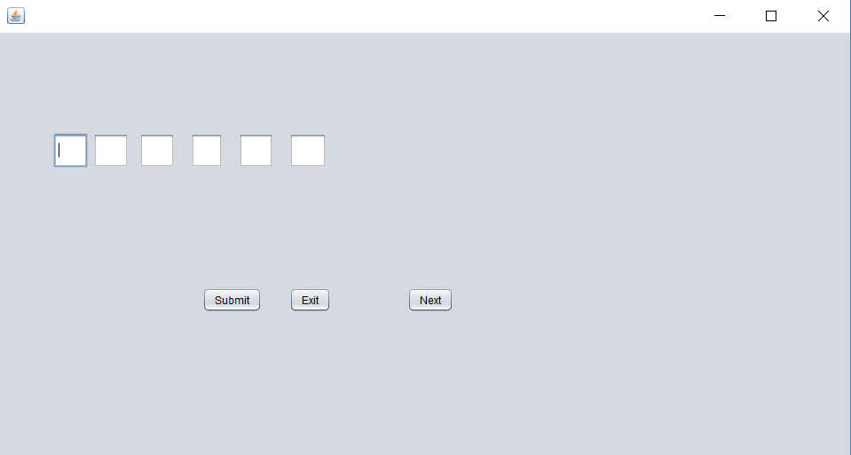

medium.java (Code) →

IMPORT STATEMENTS

import java.sql.*;

import javax.swing.*;

MEDIUM

public class medium extends javax.swing.JFrame {

public String name;

public int chance = 8;

public int wordLength = 0;

public int textFilled = 0;

public ResultSet rs;

public easy() {

initComponents();

jTextField1.setVisible(false);

jTextField2.setVisible(false);

jTextField3.setVisible(false);

jTextField4.setVisible(false);

jTextField5.setVisible(false);

jTextField6.setVisible(false);

jTextField7.setVisible(false);

jTextField8.setVisible(false);

jTextField9.setVisible(false);

jLabel1.setVisible(false);

jLabel2.setVisible(false);

jLabel3.setVisible(false);

jLabel4.setVisible(false);

jLabel5.setVisible(false);

jLabel6.setVisible(false);

jLabel7.setVisible(false);

try

{

Class.forName("com.mysql.jdbc.Driver");

Connection con= DriverManager.getConnection("jdbc:mysql://localhost/hangman","root","server");

Statement stmt = con.createStatement();

String query = "select movie_name from gamemed;" ;

rs = stmt.executeQuery(query);

rs.first();

if (rs.getString(1).equals(""))

{

JOptionPane.showMessageDialog(null, "No names in database");

System.exit(0);

}

else

{

name = rs.getString(1);

}

} catch (Exception e ){JOptionPane.showMessageDialog(null, e.getMessage());}

wordLength = name.length();

System.out.print(wordLength);

int b = 9-wordLength;

System.out.print(b);

switch (b) { case 0 : jTextField9.setVisible(true);

case 1 : jTextField8.setVisible(true);

case 2 : jTextField7.setVisible(true);

case 3 : jTextField6.setVisible(true);

case 4 : jTextField5.setVisible(true);

case 5 : jTextField4.setVisible(true);

case 6 : jTextField3.setVisible(true);

case 7 : jTextField2.setVisible(true);

case 8 : jTextField1.setVisible(true);

}

}

private void initComponents() {

jTextField1 = new javax.swing.JTextField();

jButton1 = new javax.swing.JButton();

jTextField2 = new javax.swing.JTextField();

jTextField3 = new javax.swing.JTextField();

jTextField4 = new javax.swing.JTextField();

jTextField5 = new javax.swing.JTextField();

jTextField6 = new javax.swing.JTextField();

jTextField7 = new javax.swing.JTextField();

jTextField8 = new javax.swing.JTextField();

jTextField9 = new javax.swing.JTextField();

jLabel1 = new javax.swing.JLabel();

jLabel2 = new javax.swing.JLabel();

jLabel3 = new javax.swing.JLabel();

jLabel4 = new javax.swing.JLabel();

jLabel5 = new javax.swing.JLabel();

jLabel6 = new javax.swing.JLabel();

jLabel7 = new javax.swing.JLabel();

jLabel8 = new javax.swing.JLabel();

jLabel9 = new javax.swing.JLabel();

jButton2 = new javax.swing.JButton();

jButton3 = new javax.swing.JButton();

private void ManageChance()

{

chance = chance - 1;

switch (chance){

case 7 :

jLabel1.setVisible(true);

break;

case 6 :

jLabel5.setVisible(true);

break;

case 5 :

jLabel3.setVisible(true);

break;

case 4 :

jLabel2.setVisible(true);

break;

case 3:

jLabel7.setVisible(true);

break;

case 2 :

jLabel4.setVisible(true);

break;

case 1 :

jLabel6.setVisible(true);

JOptionPane.showMessageDialog(null, "Chances over. You have lost the game");

System.exit(0);

}

}

int SanityCheckOfFields()

{

String empty = "";

int notFilled = 0;

if (empty.equalsIgnoreCase(jTextField1.getText()))

{

jTextField1.grabFocus();

empty = "";

notFilled = 1;

}

else if (empty.equalsIgnoreCase(jTextField2.getText()))

{

jTextField2.grabFocus();

empty = "";

notFilled = 2;

}

else if (empty.equalsIgnoreCase(jTextField3.getText()))

{

jTextField3.grabFocus();

empty = "";

notFilled = 3;

}

else if (empty.equalsIgnoreCase(jTextField4.getText()))

{

jTextField4.grabFocus();

empty = "";

notFilled = 4;

}

else if (empty.equalsIgnoreCase(jTextField5.getText()))

{

jTextField5.grabFocus();

empty = "";

notFilled = 5;

}

else if (empty.equalsIgnoreCase(jTextField6.getText()))

{

jTextField6.grabFocus();

empty = "";

notFilled = 6;

}

else if (empty.equalsIgnoreCase(jTextField7.getText()))

{

jTextField7.grabFocus();

empty = "";

notFilled = 7;

}

else if (empty.equalsIgnoreCase(jTextField8.getText()))

{

jTextField8.grabFocus();

empty = "";

notFilled = 8;

}

else if (empty.equalsIgnoreCase(jTextField9.getText()))

{

jTextField9.grabFocus();

empty = "";

notFilled = 9;

}

return notFilled;

}

void setTextAndFocus(JTextField txtField1, JTextField txtField2, String str)

{

txtField1.setText(str.toUpperCase());

txtField1.setEditable(false);

txtField1.setFocusable(false);

txtField2.grabFocus();

}

private void jTextField1FocusLost(java.awt.event.FocusEvent evt) {

// TODO add your handling code here:

if (SanityCheckOfFields()== 1)

{

return;

}

else

{

String charVal = jTextField1.getText();

String c ;

c = name.substring(0,1);

if (c.equalsIgnoreCase(charVal))

{

setTextAndFocus(jTextField1, jTextField2, c);

textFilled = 1;

}

else

{

ManageChance();

jTextField1.setText("");

jTextField1.grabFocus();

}

}

}

private void jTextField2FocusLost(java.awt.event.FocusEvent evt) {

// TODO add your handling code here:

if (SanityCheckOfFields()== 1 || SanityCheckOfFields()== 2)

{

return;

}

else

{

String charVal = jTextField2.getText();

String c ;

c = name.substring(1,2);

if (c.equalsIgnoreCase(charVal))

{

setTextAndFocus(jTextField2, jTextField3, c);

textFilled = 2;

}

else

{

ManageChance();

jTextField2.setText("");

jTextField2.grabFocus();

}

}

}

private void jTextField3FocusLost(java.awt.event.FocusEvent evt) {

// TODO add your handling code here:

if (SanityCheckOfFields()== 3)

{

return;

}

else

{

String empty = "";

if (empty.equalsIgnoreCase(jTextField2.getText()))

{

jTextField2.grabFocus();

}

else

{

String charVal = jTextField3.getText();

String c ;

c = name.substring(2,3);

if (c.equalsIgnoreCase(charVal))

{

setTextAndFocus(jTextField3, jTextField4, c);

textFilled = 3;

}

else

{

ManageChance();

jTextField3.setText("");

jTextField3.grabFocus();

}

}

}

}

private void jTextField4FocusLost(java.awt.event.FocusEvent evt) {

// TODO add your handling code here:

if (SanityCheckOfFields()== 4)

{

return;

}

else

{

String empty = "";

if (empty.equalsIgnoreCase(jTextField3.getText()))

{

jTextField3.grabFocus();

}

else

{

String charVal = jTextField4.getText();

String c ;

c = name.substring(3,4);

if (c.equalsIgnoreCase(charVal))

{

setTextAndFocus(jTextField4, jTextField5, c);

textFilled = 4;

}

else

{

ManageChance();

jTextField4.setText("");

jTextField4.grabFocus();

}

}

}

}

private void jTextField5FocusLost(java.awt.event.FocusEvent evt) {

// TODO add your handling code here:

if (SanityCheckOfFields()== 5)

{

return;

}

else

{

String empty = "";

if (empty.equalsIgnoreCase(jTextField4.getText()))

{

jTextField4.grabFocus();

}

else

{

String charVal = jTextField5.getText();

String c ;

c = name.substring(4,5);

if (c.equalsIgnoreCase(charVal))

{

setTextAndFocus(jTextField5, jTextField6, c);

textFilled = 5;

}

else

{

ManageChance();

jTextField5.setText("");

jTextField5.grabFocus();

}

}

}

}

private void jTextField6FocusLost(java.awt.event.FocusEvent evt) {

// TODO add your handling code here:

if (SanityCheckOfFields()== 6)

{

return;

}

else

{

String empty = "";

if (empty.equalsIgnoreCase(jTextField5.getText()))

{

jTextField5.grabFocus();

}

else

{

String charVal = jTextField6.getText();

String c ;

c = name.substring(5,6);

if (c.equalsIgnoreCase(charVal))

{

setTextAndFocus(jTextField6, jTextField7, c);

textFilled = 6;

}

else

{

ManageChance();

jTextField6.setText("");

jTextField6.grabFocus();

}

}

}

}

private void jTextField7FocusLost(java.awt.event.FocusEvent evt) {

// TODO add your handling code here:

if (SanityCheckOfFields()== 7)

{

return;

}

else

{

String empty = "";

if (empty.equalsIgnoreCase(jTextField6.getText()))

{

jTextField6.grabFocus();

}

else

{

String charVal = jTextField7.getText();

String c ;

c = name.substring(6,7);

if (c.equalsIgnoreCase(charVal))

{

setTextAndFocus(jTextField7, jTextField8, c);

textFilled = 7;

}

else

{

ManageChance();

jTextField7.setText("");

jTextField7.grabFocus();

}

}

}

}

private void jTextField8FocusLost(java.awt.event.FocusEvent evt) {

// TODO add your handling code here:

if (SanityCheckOfFields()== 8)

{

return;

}

else

{

String empty = "";

if (empty.equalsIgnoreCase(jTextField7.getText()))

{

jTextField7.grabFocus();

}

else

{

String charVal = jTextField8.getText();

String c ;

c = name.substring(7,8);

if (c.equalsIgnoreCase(charVal))

{

setTextAndFocus(jTextField8, jTextField9, c);

textFilled = 8;

}

else

{

ManageChance();

jTextField8.setText("");

jTextField8.grabFocus();

}

}

}

}

private void jTextField9FocusLost(java.awt.event.FocusEvent evt) {

// TODO add your handling code here:

if (SanityCheckOfFields()== 9)

{

return;

}

else

{

String empty = "";

if (empty.equalsIgnoreCase(jTextField8.getText()))

{

jTextField8.grabFocus();

}

else

{

String charVal = jTextField9.getText();

String c ;

c = name.substring(8,9);

if (c.equalsIgnoreCase(charVal))

{

setTextAndFocus(jTextField9, jTextField9, c);

textFilled = 9;

}

else

{

ManageChance();

jTextField9.setText("");

jTextField9.grabFocus();

}

}

}

}

private void jButton1MousePressed(java.awt.event.MouseEvent evt) {

// TODO add your handling code here:

if (textFilled != wordLength)

{

JOptionPane.showMessageDialog(null, "Please enter name letter to play the game");

}

else

{

JOptionPane.showMessageDialog(null, "You have won the game. Press Next to Play Another round");

}

}

private void jButton2MousePressed(java.awt.event.MouseEvent evt) {

// TODO add your handling code here:

JOptionPane.showMessageDialog(null, "Exiting game");

System.exit(0);

}

void RefreshTextFields(JTextField jTxtField)

{

jTxtField.setVisible(true);

jTxtField.setFocusable(true);

jTxtField.setText("");

jTxtField.setEditable(true);

}

private void jButton3ActionPerformed(java.awt.event.ActionEvent evt) {

// TODO add your handling code here:

chance = 8;

wordLength = 0;

textFilled = 0;

//initComponents();

jTextField1.setVisible(false);

jTextField2.setVisible(false);

jTextField3.setVisible(false);

jTextField4.setVisible(false);

jTextField5.setVisible(false);

jTextField6.setVisible(false);

jTextField7.setVisible(false);

jTextField8.setVisible(false);

jTextField9.setVisible(false);

jLabel1.setVisible(false);

jLabel2.setVisible(false);

jLabel3.setVisible(false);

jLabel4.setVisible(false);

jLabel5.setVisible(false);

jLabel6.setVisible(false);

jLabel7.setVisible(false);

try

{

//while (rs.next())

//{

if (rs.next())

{

name = rs.getString(1);

}

else

{

rs.first();

name = rs.getString(1);

}

//}

} catch (Exception e ){JOptionPane.showMessageDialog(null, e.getMessage());}

wordLength = name.length();

System.out.print(wordLength);

int b = 9-wordLength;

System.out.print(b);

switch (b) { case 0 : RefreshTextFields(jTextField9);

case 1 : RefreshTextFields(jTextField8);

case 2 : RefreshTextFields(jTextField7);

case 3 : RefreshTextFields(jTextField6);

case 4 : RefreshTextFields(jTextField5);

case 5 : RefreshTextFields(jTextField4);

case 6 : RefreshTextFields(jTextField3);

case 7 : RefreshTextFields(jTextField2);

case 8 : RefreshTextFields(jTextField1);

jTextField1.grabFocus();

}

}

Hard frame:

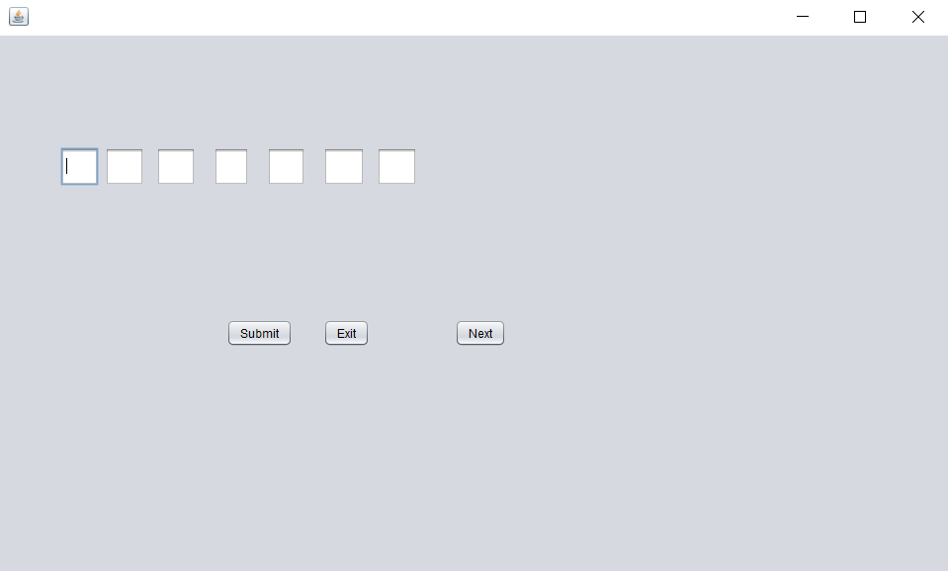

Hard.java (Code) →

IMPORT STATEMENTS

import java.sql.*;

import javax.swing.*;

HARD

public class easy extends javax.swing.JFrame {

public String name;

public int chance = 8;

public int wordLength = 0;

public int textFilled = 0;

public ResultSet rs;

public easy() {

initComponents();

jTextField1.setVisible(false);

jTextField2.setVisible(false);

jTextField3.setVisible(false);

jTextField4.setVisible(false);

jTextField5.setVisible(false);

jTextField6.setVisible(false);

jTextField7.setVisible(false);

jTextField8.setVisible(false);

jTextField9.setVisible(false);

jLabel1.setVisible(false);

jLabel2.setVisible(false);

jLabel3.setVisible(false);

jLabel4.setVisible(false);

jLabel5.setVisible(false);

jLabel6.setVisible(false);

jLabel7.setVisible(false);

try

{

Class.forName("com.mysql.jdbc.Driver");

Connection con= DriverManager.getConnection("jdbc:mysql://localhost/hangman","root","server");

Statement stmt = con.createStatement();

String query = "select movie_name from gamehard;" ;

rs = stmt.executeQuery(query);

rs.first();

if (rs.getString(1).equals(""))

{

JOptionPane.showMessageDialog(null, "No names in database");

System.exit(0);

}

else

{

name = rs.getString(1);

}

} catch (Exception e ){JOptionPane.showMessageDialog(null, e.getMessage());}

wordLength = name.length();

System.out.print(wordLength);

int b = 9-wordLength;

System.out.print(b);

switch (b) { case 0 : jTextField9.setVisible(true);

case 1 : jTextField8.setVisible(true);

case 2 : jTextField7.setVisible(true);

case 3 : jTextField6.setVisible(true);

case 4 : jTextField5.setVisible(true);

case 5 : jTextField4.setVisible(true);

case 6 : jTextField3.setVisible(true);

case 7 : jTextField2.setVisible(true);

case 8 : jTextField1.setVisible(true);

}

}

private void initComponents() {

jTextField1 = new javax.swing.JTextField();

jButton1 = new javax.swing.JButton();

jTextField2 = new javax.swing.JTextField();

jTextField3 = new javax.swing.JTextField();

jTextField4 = new javax.swing.JTextField();

jTextField5 = new javax.swing.JTextField();

jTextField6 = new javax.swing.JTextField();

jTextField7 = new javax.swing.JTextField();

jTextField8 = new javax.swing.JTextField();

jTextField9 = new javax.swing.JTextField();

jLabel1 = new javax.swing.JLabel();

jLabel2 = new javax.swing.JLabel();

jLabel3 = new javax.swing.JLabel();

jLabel4 = new javax.swing.JLabel();

jLabel5 = new javax.swing.JLabel();

jLabel6 = new javax.swing.JLabel();

jLabel7 = new javax.swing.JLabel();

jLabel8 = new javax.swing.JLabel();

jLabel9 = new javax.swing.JLabel();

jButton2 = new javax.swing.JButton();

jButton3 = new javax.swing.JButton();

private void ManageChance()

{

chance = chance - 1;

switch (chance){

case 7 :

jLabel1.setVisible(true);

break;

case 6 :

jLabel5.setVisible(true);

break;

case 5 :

jLabel3.setVisible(true);

break;

case 4 :

jLabel2.setVisible(true);

break;

case 3:

jLabel7.setVisible(true);

break;

case 2 :

jLabel4.setVisible(true);

break;

case 1 :

jLabel6.setVisible(true);

JOptionPane.showMessageDialog(null, "Chances over. You have lost the game");

System.exit(0);

}

}

int SanityCheckOfFields()

{

String empty = "";

int notFilled = 0;

if (empty.equalsIgnoreCase(jTextField1.getText()))

{

jTextField1.grabFocus();

empty = "";

notFilled = 1;

}

else if (empty.equalsIgnoreCase(jTextField2.getText()))

{

jTextField2.grabFocus();

empty = "";

notFilled = 2;

}

else if (empty.equalsIgnoreCase(jTextField3.getText()))

{

jTextField3.grabFocus();

empty = "";

notFilled = 3;

}

else if (empty.equalsIgnoreCase(jTextField4.getText()))

{

jTextField4.grabFocus();

empty = "";

notFilled = 4;

}

else if (empty.equalsIgnoreCase(jTextField5.getText()))

{

jTextField5.grabFocus();

empty = "";

notFilled = 5;

}

else if (empty.equalsIgnoreCase(jTextField6.getText()))

{

jTextField6.grabFocus();

empty = "";

notFilled = 6;

}

else if (empty.equalsIgnoreCase(jTextField7.getText()))

{

jTextField7.grabFocus();

empty = "";

notFilled = 7;

}

else if (empty.equalsIgnoreCase(jTextField8.getText()))

{

jTextField8.grabFocus();

empty = "";

notFilled = 8;

}

else if (empty.equalsIgnoreCase(jTextField9.getText()))

{

jTextField9.grabFocus();

empty = "";

notFilled = 9;

}

return notFilled;

}

void setTextAndFocus(JTextField txtField1, JTextField txtField2, String str)

{

txtField1.setText(str.toUpperCase());

txtField1.setEditable(false);

txtField1.setFocusable(false);

txtField2.grabFocus();

}

private void jTextField1FocusLost(java.awt.event.FocusEvent evt) {

// TODO add your handling code here:

if (SanityCheckOfFields()== 1)

{

return;

}

else

{

String charVal = jTextField1.getText();

String c ;

c = name.substring(0,1);

if (c.equalsIgnoreCase(charVal))

{

setTextAndFocus(jTextField1, jTextField2, c);

textFilled = 1;

}

else

{

ManageChance();

jTextField1.setText("");

jTextField1.grabFocus();

}

}

}

private void jTextField2FocusLost(java.awt.event.FocusEvent evt) {

// TODO add your handling code here:

if (SanityCheckOfFields()== 1 || SanityCheckOfFields()== 2)

{

return;

}

else

{

String charVal = jTextField2.getText();

String c ;

c = name.substring(1,2);

if (c.equalsIgnoreCase(charVal))

{

setTextAndFocus(jTextField2, jTextField3, c);

textFilled = 2;

}

else

{

ManageChance();

jTextField2.setText("");

jTextField2.grabFocus();

}

}

}

private void jTextField3FocusLost(java.awt.event.FocusEvent evt) {

// TODO add your handling code here:

if (SanityCheckOfFields()== 3)

{

return;

}

else

{

String empty = "";

if (empty.equalsIgnoreCase(jTextField2.getText()))

{

jTextField2.grabFocus();

}

else

{

String charVal = jTextField3.getText();

String c ;

c = name.substring(2,3);

if (c.equalsIgnoreCase(charVal))

{

setTextAndFocus(jTextField3, jTextField4, c);

textFilled = 3;

}

else

{

ManageChance();

jTextField3.setText("");

jTextField3.grabFocus();

}

}

}

}

private void jTextField4FocusLost(java.awt.event.FocusEvent evt) {

// TODO add your handling code here:

if (SanityCheckOfFields()== 4)

{

return;

}

else

{

String empty = "";

if (empty.equalsIgnoreCase(jTextField3.getText()))

{

jTextField3.grabFocus();

}

else

{

String charVal = jTextField4.getText();

String c ;

c = name.substring(3,4);

if (c.equalsIgnoreCase(charVal))

{

setTextAndFocus(jTextField4, jTextField5, c);

textFilled = 4;

}

else

{

ManageChance();

jTextField4.setText("");

jTextField4.grabFocus();

}

}

}

}

private void jTextField5FocusLost(java.awt.event.FocusEvent evt) {

// TODO add your handling code here:

if (SanityCheckOfFields()== 5)

{

return;

}

else

{

String empty = "";

if (empty.equalsIgnoreCase(jTextField4.getText()))

{

jTextField4.grabFocus();

}

else

{

String charVal = jTextField5.getText();

String c ;

c = name.substring(4,5);

if (c.equalsIgnoreCase(charVal))

{

setTextAndFocus(jTextField5, jTextField6, c);

textFilled = 5;

}

else

{

ManageChance();

jTextField5.setText("");

jTextField5.grabFocus();

}

}

}

}

private void jTextField6FocusLost(java.awt.event.FocusEvent evt) {

// TODO add your handling code here:

if (SanityCheckOfFields()== 6)

{

return;

}

else

{

String empty = "";

if (empty.equalsIgnoreCase(jTextField5.getText()))

{

jTextField5.grabFocus();

}

else

{

String charVal = jTextField6.getText();

String c ;

c = name.substring(5,6);

if (c.equalsIgnoreCase(charVal))

{

setTextAndFocus(jTextField6, jTextField7, c);

textFilled = 6;

}

else

{

ManageChance();

jTextField6.setText("");

jTextField6.grabFocus();

}

}

}

}

private void jTextField7FocusLost(java.awt.event.FocusEvent evt) {

// TODO add your handling code here:

if (SanityCheckOfFields()== 7)

{

return;

}

else

{

String empty = "";

if (empty.equalsIgnoreCase(jTextField6.getText()))

{

jTextField6.grabFocus();

}

else

{

String charVal = jTextField7.getText();

String c ;

c = name.substring(6,7);

if (c.equalsIgnoreCase(charVal))

{

setTextAndFocus(jTextField7, jTextField8, c);

textFilled = 7;

}

else

{

ManageChance();

jTextField7.setText("");

jTextField7.grabFocus();

}

}

}

}

private void jTextField8FocusLost(java.awt.event.FocusEvent evt) {

// TODO add your handling code here:

if (SanityCheckOfFields()== 8)

{

return;

}

else

{

String empty = "";

if (empty.equalsIgnoreCase(jTextField7.getText()))

{

jTextField7.grabFocus();

}

else

{

String charVal = jTextField8.getText();

String c ;

c = name.substring(7,8);

if (c.equalsIgnoreCase(charVal))

{

setTextAndFocus(jTextField8, jTextField9, c);

textFilled = 8;

}

else

{

ManageChance();

jTextField8.setText("");

jTextField8.grabFocus();

}

}

}

}

private void jTextField9FocusLost(java.awt.event.FocusEvent evt) {

// TODO add your handling code here:

if (SanityCheckOfFields()== 9)

{

return;

}

else

{

String empty = "";

if (empty.equalsIgnoreCase(jTextField8.getText()))

{

jTextField8.grabFocus();

}

else

{

String charVal = jTextField9.getText();

String c ;

c = name.substring(8,9);

if (c.equalsIgnoreCase(charVal))

{

setTextAndFocus(jTextField9, jTextField9, c);

textFilled = 9;

}

else

{

ManageChance();

jTextField9.setText("");

jTextField9.grabFocus();

}

}

}

}

private void jButton1MousePressed(java.awt.event.MouseEvent evt) {

// TODO add your handling code here:

if (textFilled != wordLength)

{

JOptionPane.showMessageDialog(null, "Please enter name letter to play the game");

}

else

{

JOptionPane.showMessageDialog(null, "You have won the game. Press Next to Play Another round");

}

}

private void jButton2MousePressed(java.awt.event.MouseEvent evt) {

// TODO add your handling code here:

JOptionPane.showMessageDialog(null, "Exiting game");

System.exit(0);

}

void RefreshTextFields(JTextField jTxtField)

{

jTxtField.setVisible(true);

jTxtField.setFocusable(true);

jTxtField.setText("");

jTxtField.setEditable(true);

}

private void jButton3ActionPerformed(java.awt.event.ActionEvent evt) {

// TODO add your handling code here:

chance = 8;

wordLength = 0;

textFilled = 0;

//initComponents();

jTextField1.setVisible(false);

jTextField2.setVisible(false);

jTextField3.setVisible(false);

jTextField4.setVisible(false);

jTextField5.setVisible(false);

jTextField6.setVisible(false);

jTextField7.setVisible(false);

jTextField8.setVisible(false);

jTextField9.setVisible(false);

jLabel1.setVisible(false);

jLabel2.setVisible(false);

jLabel3.setVisible(false);

jLabel4.setVisible(false);

jLabel5.setVisible(false);

jLabel6.setVisible(false);

jLabel7.setVisible(false);

try

{

//while (rs.next())

//{

if (rs.next())

{

name = rs.getString(1);

}

else

{

rs.first();

name = rs.getString(1);

}

//}

} catch (Exception e ){JOptionPane.showMessageDialog(null, e.getMessage());}

wordLength = name.length();

System.out.print(wordLength);

int b = 9-wordLength;

System.out.print(b);

switch (b) { case 0 : RefreshTextFields(jTextField9);

case 1 : RefreshTextFields(jTextField8);

case 2 : RefreshTextFields(jTextField7);

case 3 : RefreshTextFields(jTextField6);

case 4 : RefreshTextFields(jTextField5);

case 5 : RefreshTextFields(jTextField4);

case 6 : RefreshTextFields(jTextField3);

case 7 : RefreshTextFields(jTextField2);

case 8 : RefreshTextFields(jTextField1);

jTextField1.grabFocus();

}

}

While playing:

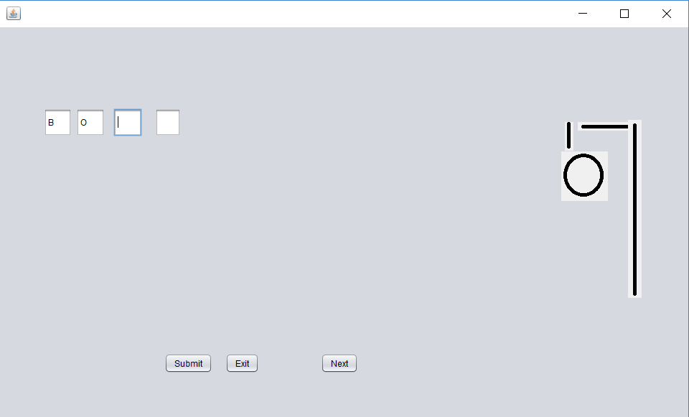

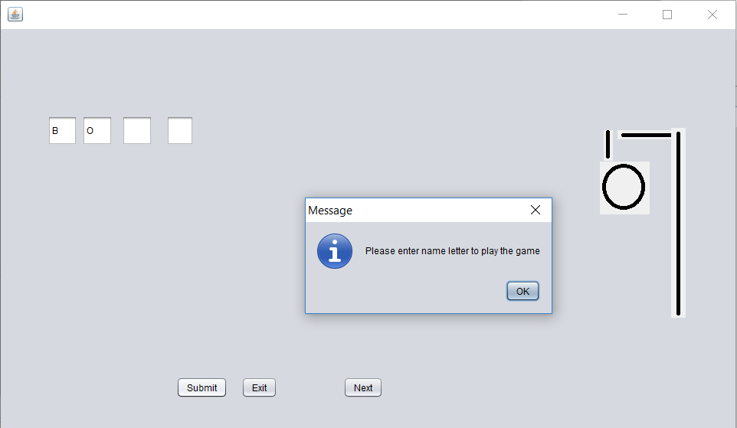

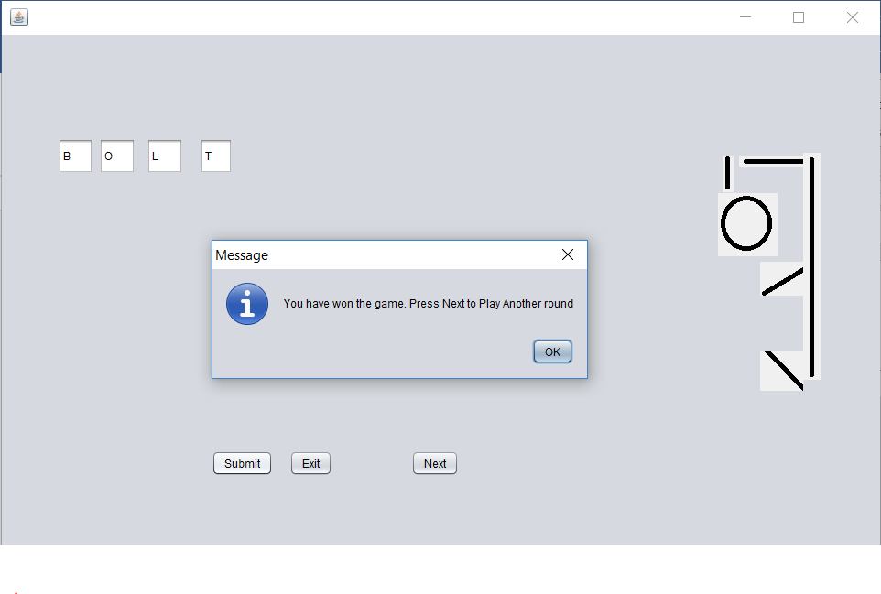

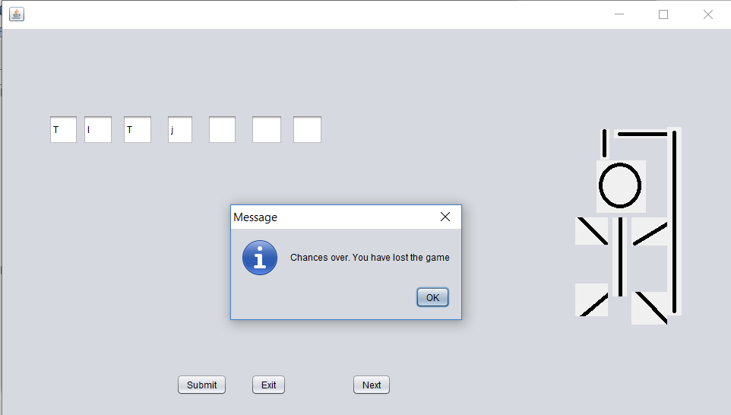

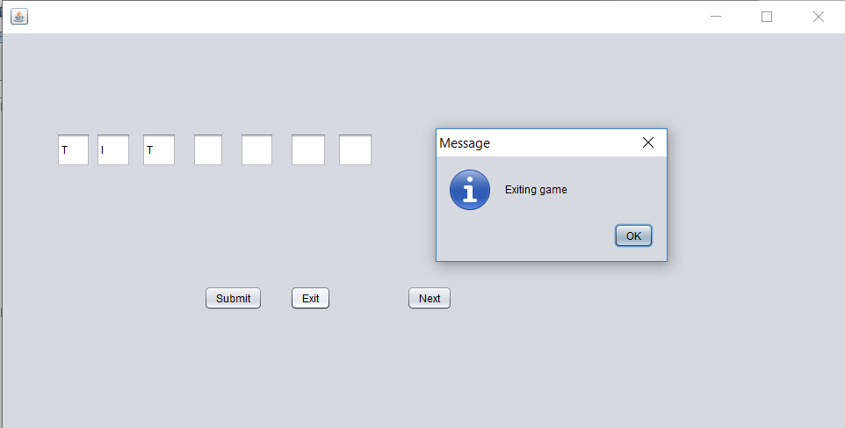

Bibliography

Books:

* NCERT Textbook Informatics Practices for class 12
* Informatics Practices for class 12 by Sumita Arora
* Informatics Practices for class 11 by Sumita Arora

Websites:

* [www.google.co.in](http://www.google.co.in/)
* [www.en.wikipedia.com](http://www.en.wikipedia.com/)
* [www.ncert.nic.in](http://www.ncert.nic.in/)